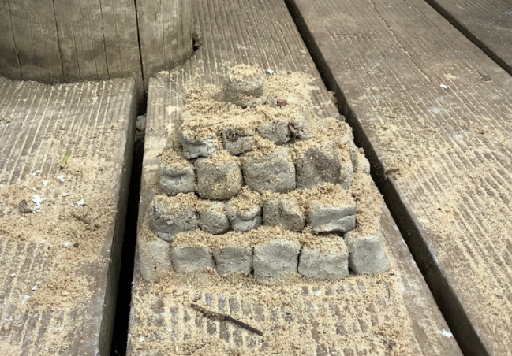
Class 3 made pyramids during the Egyptian topic (links with DT and Maths)
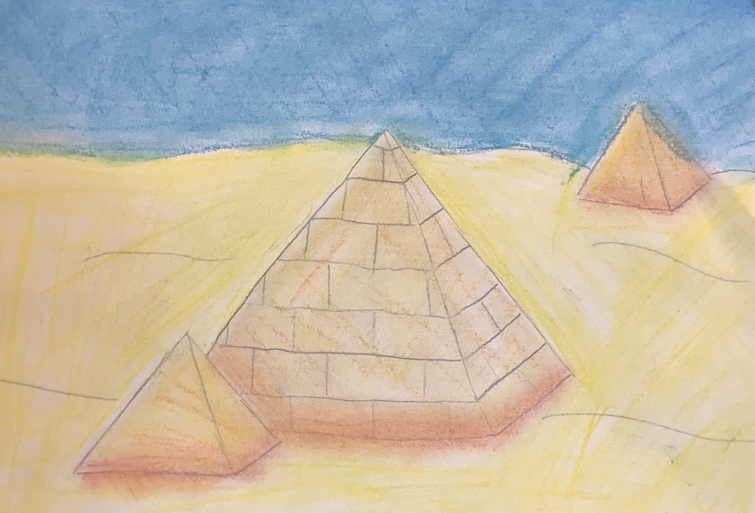
Links with Art.

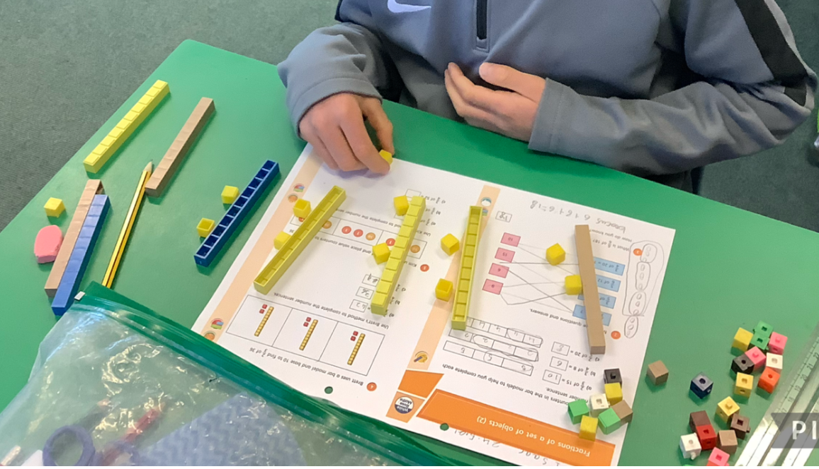
Using dienes equipment for work on Place Value

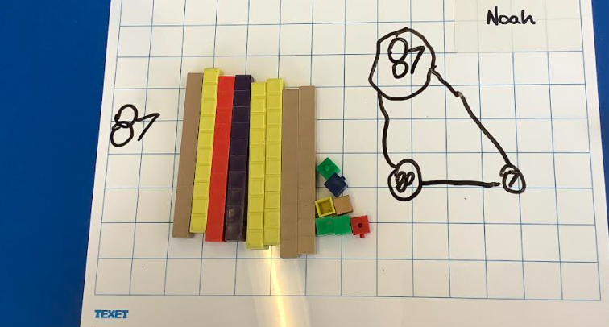
Using dienes equipment to help with partitioning and building numbers
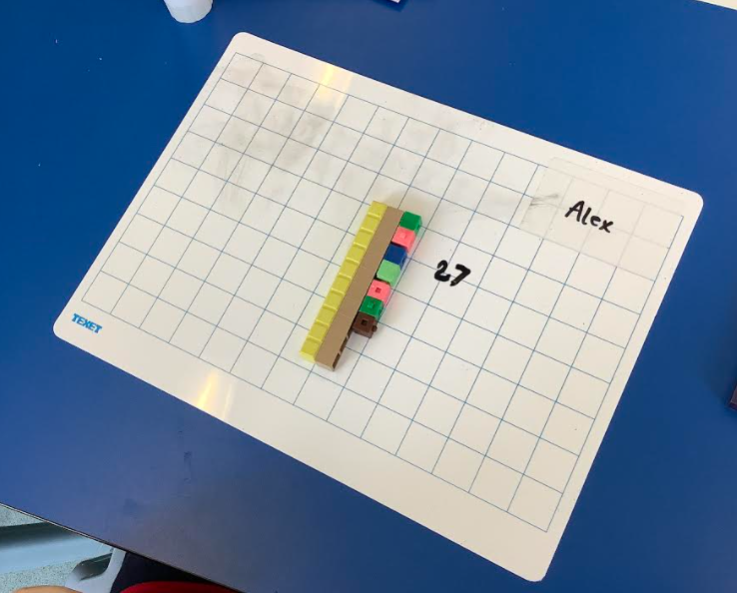

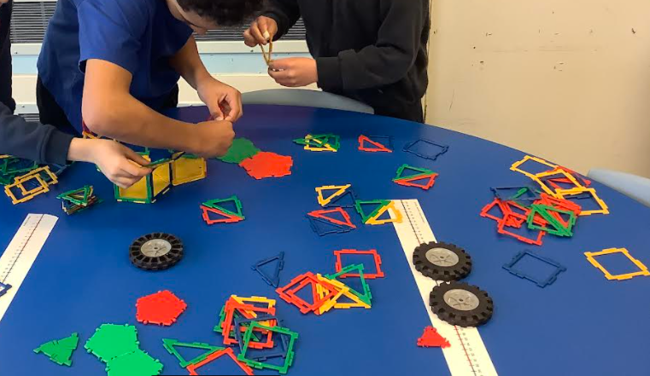
Building towers during a topic about Earthquakes.
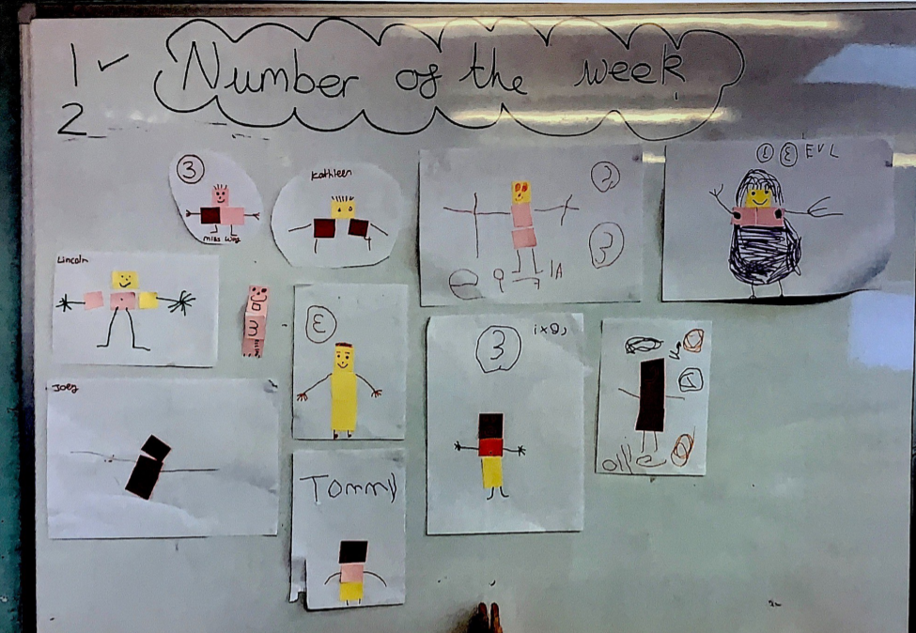
Number of the week in EYFS

Number day 4th February 2022
​

