UMaths Framework of Expectations

At Greenfields we follow the White Rose Scheme of work and the White Rose calculation policy.
Long term plans are taken from the White Rose Scheme of Work (see appendix for example)

Medium Term Planning

Medium term planning follows a standard format (see appendix) for yr1-6 and is given to the Maths Lead at the start of the unit. EYFS to submit half termly plans also.
These plans are working documents and will be annotated and altered as necessary and then used to inform future planning, interventions and support.
The ‘Areas of Weakness’ section of the MTP may include any GAPS from the previous unit.

Short Term Planning

All planning follows the ‘small steps’ at the pace of the class. A ‘small step’ could be one lesson but the children may need consolidation before they move on. The consolidation work may come from other sources eg classroom secrets, target your maths, tes.
In the children’s workbooks, sections of the small steps can be crossed out at the teacher’s discretion in order to move onto the reasoning and problem solving challenges.
There is no set format for daily planning and this does not need to be given in however there must be evidence on the plans of how understanding will be checked, key questions, vocabulary to be used and possible scaffolding/modelling in line with the teaching and learning framework of expectations.
Personalisation:
Pre-learning and re-capping will be planned in to the daily session and delivered by the Class Teacher or a TA.
SEND and PP children should be acknowledged when planning lessons to ensure that they are accessing learning at the appropriate ability level.
Additional resource packs will be issued as required.
Where further structured interventions are needed, sessions are planned for and delivered outside of the Maths lessons. This may include Power of 2, Plus 1, 1 minute maths etc.

Lesson Structure/ Stages of Learning

Each lesson will start with a fluency session or consolidation
We follow the CPA (concrete, pictorial, abstract) approach and manipulatives are readily available.
WR workbooks will be used as the basis of the lesson (yr1-6)
Live marking and discussion about misconceptions will take place throughout the lesson.
Any workbooks and challenges not marked in the lesson will be marked before the next lesson in order that mistakes can be discussed and corrected.
Corrections need to be completed and remarked.
Children should be encouraged to mark their own work and then correct this where possible
TAs must be deployed effectively to support learning
The language of learning characteristics are to be encouraged throughout the lesson, eg risk taker, independent learner, collaborative, resilient.
Plenary sessions will recap concepts from the lesson and discussions addressing misconceptions and common errors.

Presentation:

Workbooks must have the date next to or under the small step and the date must also be put in the Maths book next to any reasoning or consolidation.
Evidence of reasoning to be shown in Maths books- question on the left, answer on the right. Digits should be formed correctly and modelled if incorrect.
Any lines or charts to be drawn with ruler.
Reasoning books must be marked following each session.
In WR workbooks, teachers may cross out a question if children have been asked not to complete it. This will also enable LA children to access opportunities to develop reasoning skills.
Indicate by the Small Step title if a child is absent. These pages will be completed upon the child’s return or sent home unless class teacher decides otherwise.

Assessment

Formative assessments:
AFL will take place in every lesson through discussions, live marking and feedback.
Children will be encouraged to complete the ‘Challenge’ questions when they demonstrate an understanding of the concept. ‘Challenge’ questions may also be completed in a small group with an adult to further develop learning.

Summative assessments:
White Rose End of Unit A tests are implemented, The results, along with a GAPS analysis is shared with the Maths Lead and informs pupil progress discussions.
Teachers will inform the Maths Leads of how and when the Gaps will be plugged and then the children will re-sit the same type of question on Test B to determine if they have a better understanding of the concept. Teachers will indicate on the results sheet when a child has understood the concept with further dated annotations.
End of unit tests will be marked, corrected and stuck in the children’s Maths books
A results sheet must be completed in the agreed format:
Green indicates full marks
Amber indicates part marks
Red indicates no marks
Using this method of presenting results demonstrates where the misunderstandings or lack of knowledge are.
The end of unit tests inform planning for intervention/ booster groups and discussions regarding pupil progress.

NTS tests are held termly. These are marked and the results uploaded onto Rising Stars and Arbor by the given deadlines.
A GAPS analysis for each year group must be carried out and the areas of weakness shared with the Maths Lead. This is used to inform the next term/ unit planning.
The Rising Stars data sheet must be shared with the Maths Lead and an overview of the whole school/hub created and shared

EYFS:
Assessment against Early Learning Goals and Development Matters statements are completed by class teacher.
Maths assessment booklets are produced to provide evidence against the Maths strands.
Evidence of class learning is demonstrated in a floor book.
Continuous provision, in the classroom and the outdoor environment enables children to access maths activities and resources through play based learning.

Learning environment
For the display policy – see appendix
Manipulatives are readily available in all classrooms. Resources that are used less frequently are kept in a central store.

Appendix

Example of medium term planning (yr4)

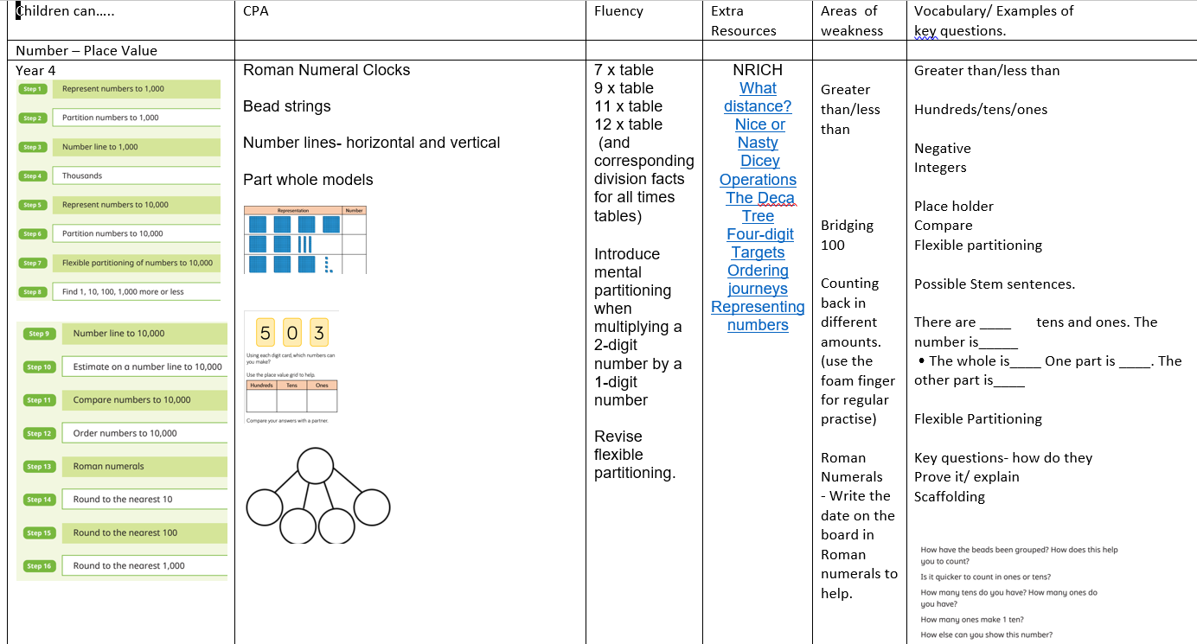

EYFS Maths Medium Term Planning – Autumn 1 - 2022
Week | Mental/Oral Starter | Objective | Activities/Assessment | Books or other prompts to support mathematical learning.
Week 1  5th September | Learning rules and routines of classroom.  Settling in and getting to know peers.  Baseline assessments.
Week 2
12th September
Week 3
19th September
Week 4  26th September | Subitising objects to 5 | Develop fast recognition of up to 3 objects without having to count them individually – subitising.  Recite numbers past 5. | Number rhymes – using objects to represent parts of number rhymes.  Use musical beats to represent numbers in number rhymes.  Focusing on number rhymes that do not go above 5 to encourage subitising. | Number Rhymes – 5 little monkeys, 5 little ducks, 1,2,3,4,5, 5 little men in a flying saucer.
Week 5  26th September | Subitising objects to 5 | Talk about and identify the patterns around them – similarities and differences between objects. | Identify whether an item is similar or different to another item – what are the similarities and what are the differences.  Play snap and other matching games to develop quick recognition of similarities and differences – building on subitising from last week.  Play dominoes – to develop matching skills. | It’s the bear – Jez Albrough  Peach at Last - Jill Murphey  Dear Zoo – Rod Campbell  Monkey Puzzle – Julia Donaldson  Autumn leaves – look at and talk about similarities and differences between autumn leaves.

Example of long term plan (yr4)
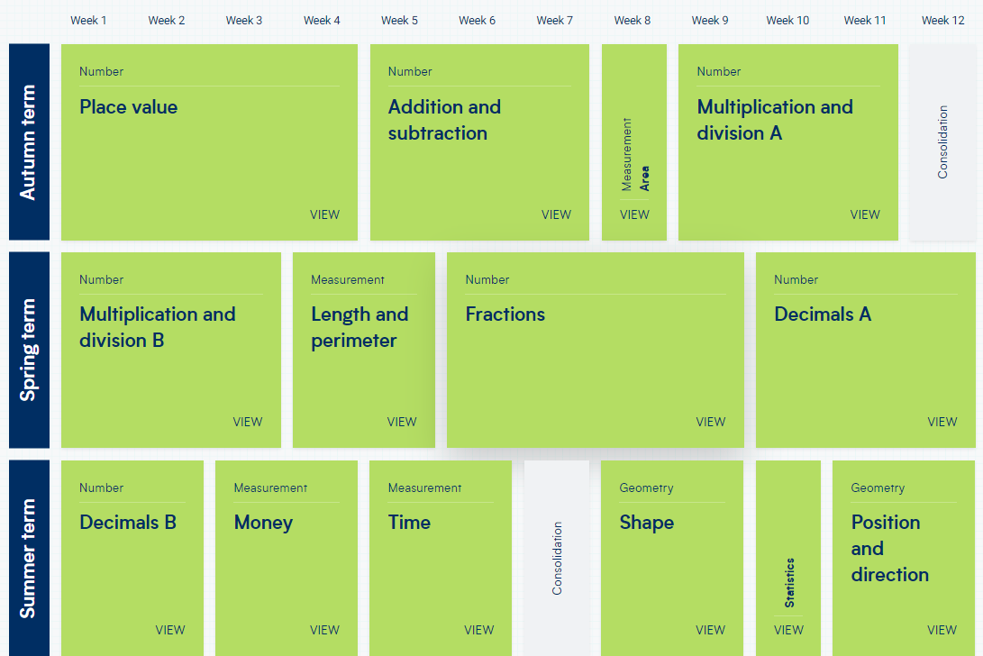

Example of year4 Place Value results sheet (not ticked/dated)

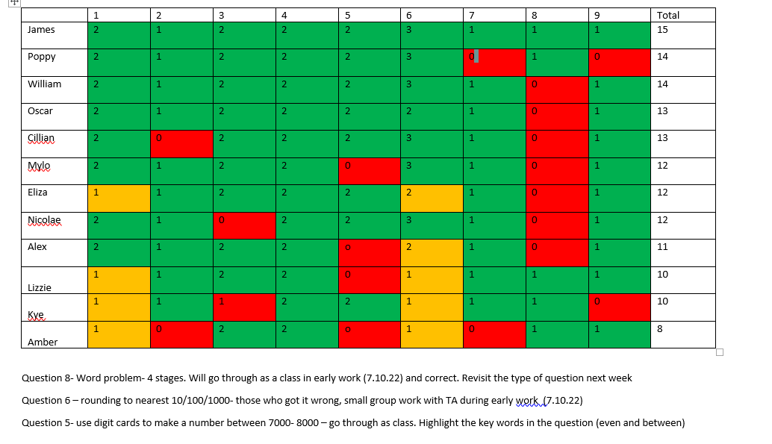

Maths display policy statement:

Black subject heading (Instant Display lettering)
Working wall: Name of topic being covered that week- ie Multiplication
Key vocabulary
Worked example
Misconceptions/easy mistakes to make (ie remember to exchange when doing column subtraction)
Posters relevant to the subject if they help understanding.
Manipulatives to be used – stuck on or drawn examples (ie tens frame and counters, drawn place value chart or bar model)
For EYFS- numbers shown in different representations
Any questions for the children to answer or things to think about (What’s the same, what’s different?)
KS2- relevance to everyday life- I buy 3 chocolate bars at 59p each. How much will that cost?

